SMART EEG headset Test Run Results

### Test Run 1:

Date: 15/10/2020

Time: 10:00 AM

Band of Interest: Alpha

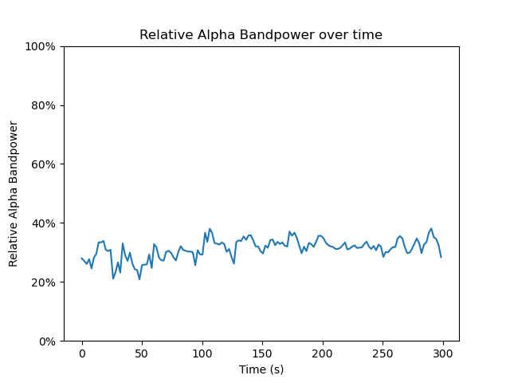

### Test Run 2:

Date:17/10/2020

Time: 12:00 PM

Band of Interest: Alpha

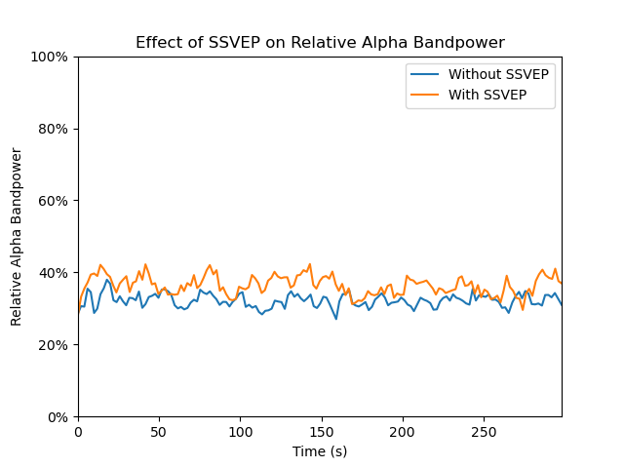

### Test Run 3: Date: 18/10/2020

Time: 10:00 AM

Band of Interest: Alpha

### 

### Test Run 4:

Date:20/10/2020

Time: 11:00 AM

Band of Interest: Alpha

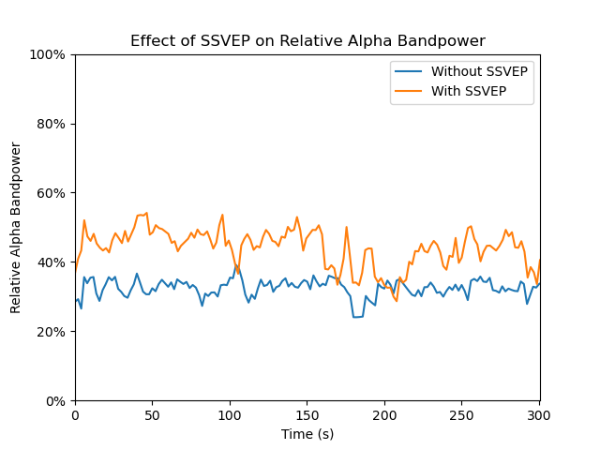

### Test Run 5:

Date:20/10/2020

Time: 1:00 PM

Band of Interest: Theta

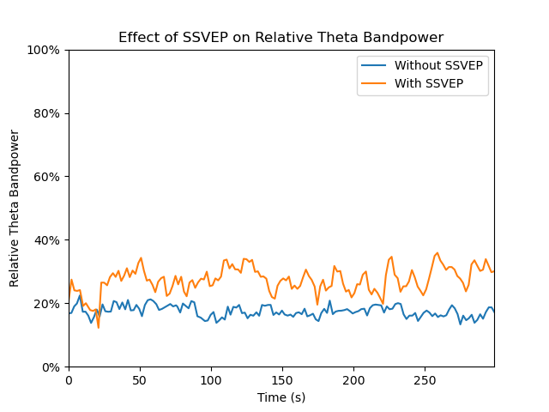

### Test Run 6:

Date:21/10/2020

Time: 10:00 AM

Band of Interest: Beta

